# Workshop

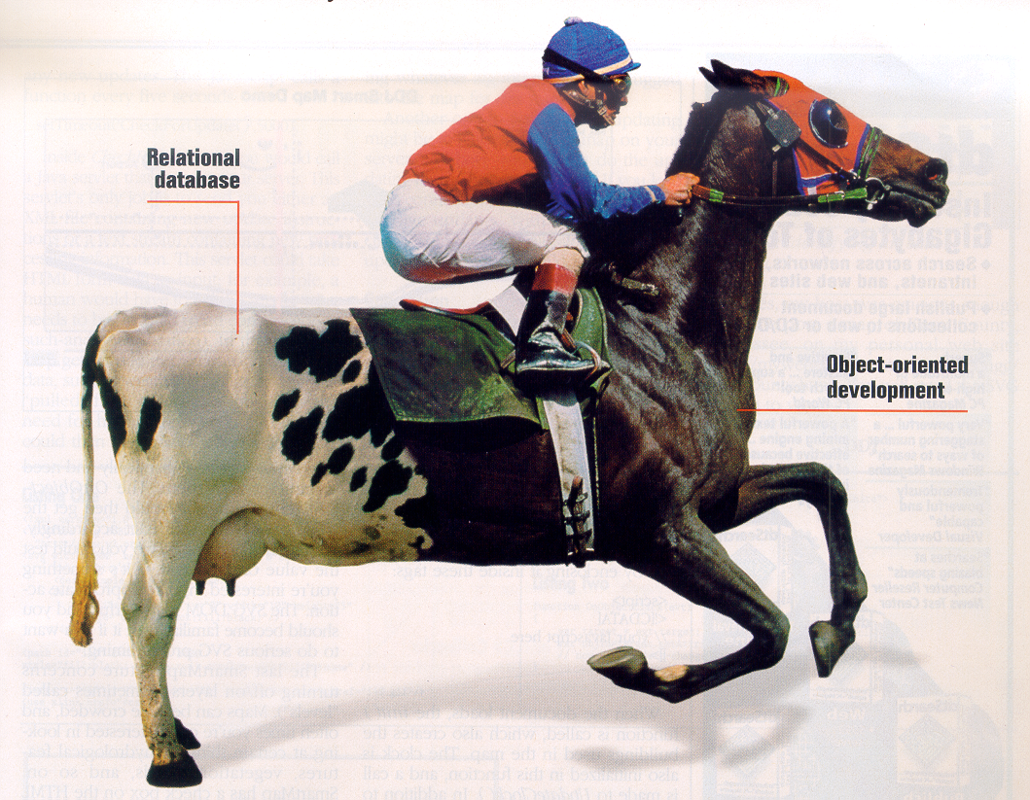

# Persistence

# 

Workshop 1

Persistence 1

Objective: 2

Intended Learning Outcome 2

Working Methods 2

About the workshop 3

Student material 3

Literature 3

Demands for documentations 3

Evaluation 4

Assignments 4

Western Style Ltd. 5

Economic review/summary 7

Profit and loss account 7

(DKK 1000,-) 7

Balance (sheet) 7

# Objective:

To get knowledge about activities in connection with creation and maintenance of databases and to get experience with accessing databases from Java programs.

# Intended Learning Outcome

* Being able to design a database which satisfies the demands for good design
* Being able to build a system with a good architecture
* Being able to produce SQL-scripts to creation of a database, along with insertion of data
* Being able to access the database from the Java-code.

# Working Methods

Assignments are to be solved in groups, which themselves decide the distribution of work and assignments between team members.

The in-depth learning is achieved by working with the assignments of the workshop. To ensure the highest possible quality of the solutions it is important that you work at the Academy where problems can be discussed with team members and supervisors.

If you experience problems in the team working process, contact a supervisor for a meeting before problems get out of hand.

The database has to be located on balder.ucn.dk. You have to use a version control system.

# About the workshop

The plan for the workshop is the following:

Day 1 Introduction to the assignment

Dag 2 Milestone:

Working papers about domain models, interaction diagams, testcases, relational models together with SQL-scripts for creation of the database and basic access to *Product* are to be reviewed.

Day 3 Working with the assignments.

Day 4 Working with the assignments.

Day 5 Working with the assignments.

Day 6 Hand in of assignments at no later than 12.00 in the reception.

The souce code is to be delivered in the form of a mail sent to GUAN and KBHA including following information

* + - * + Repository path
        + Revision number

Supervisors (GUAN and KBHA) will be available most days.

# Student material

The following material will be available on the intranet:

Lecture note: Persistence, An Example Architecture for Encapsulation of Database Access in Java Systems

A basic example in how to use JDBC (in *Company*-example)

Slides from the lecture

# Literature

Elmasri.

# Demands for documentations

* Fully dressed use-case description for order processing and relevant documentation for that use-case.
* Interaction diagrams for the fully dressed use-case
* Interpretations of the domain model and maybe an modified model.
* Description of the relational database design.
* SQL scripts for creation of the database.
* SQL scripts for insertion of data into the database.
* Description of testscases carried out. The testclasses has to be part of the Eclipse project.
* Your final program as a Eclipse project.
* Your database is located on balder.ucn.dk

The documentation must be in one document (word or pdf).

# Evaluation

**1th of November**. The teams demonstrate and review/discuss the developed database program (approximately 40 min. each team < 3 and 30 min team <=3).

Group 1 8.30 – 9.10

Group 2 9.10 – 9.50

Group 3 9.50 – 10.30

Group 4 10.30 – 11.10

Group 5 11.10 – 11.50

Lunch 11.50 – 12.15

Group 6 12.15 - 12.55

Group 7 12.55 - 13.25

## Assignments

From the case “Western Style Ltd.” your assignment is to create part of a computer system. This work will give you the possibility to build a system in Java using a relational database.

The domain model is not complete/correct, so if you should discover some errors/mistakes it is your job to make the necessary adjustments (in the model). In the first version of the system, you may want not to implement the specialisation hierarchy modelling different products.

1. Based on the domain model a relational model is to be designed (mapping/transformation).
2. Script(s) for creation of the database and insertion of data are to be written.
3. Java programs are to be created so it is possible to carry out CRUD operations on business classes.
4. Besides CRUD operations search operations are to be developed.
5. Finally the use case for order processing is to be described, designed, implemented and tested.



# Western Style Ltd.

Western Style was established in 1983 by Hanne and Børge Pedersen. The company consists of one store which is located in Viborg and furthermore the company attends festivals, markets and concerts where they promote their range of products. The concept of the company arose when Hanne and Børge attended square dance lessons and found it difficult finding stylish cowboy clothing for the dancers. First they started importing clothing only but later on also many other western related items. In the year 2002 the company was turned from a single man company into a private limited company with a stock capital of DKK 500.000,-

In the beginning it was especially the US/American market, who was the main supplier, but the company has expanded substantially, including the field/area of suppliers, and today many items comes from Hungary and Poland and Børge still visits trade fairs to find new relevant and competitive suppliers. Børge and Hanne are responsible for purchasing new products to the assortment, while inventory control and keeping supplies in stock is done by other employees in teamwork.

During the last 26 years the company has grown from being a spare time business to becoming a company with 6 employees in addition to the owners. Kent Andersen is the accountant and furthermore manages debtor and credit control. Nina Munkholm is responsible for running the store on a daily basis and makes the work plans, holiday planning and coordinates who participate in some of the arrangements in the outside world. So far sales have been limited to the Danish market and foreign tourists visiting Denmark, but the objective is to expand somewhere in the future.

The additional 4 employees manage service and sale/sales promotion along with packing and dispatching of merchandise all over the country. Today, many orders are made from societies, who place their orders from the catalogue the company put out 2 times a year. Furthermore advertising is done in dailies, magazines and trade journals.

Closer analysis and categorization of the costumers have not been done but most are square-dancer clubs, line-dancer clubs, western clubs, riding clubs with western riding disciplines and private persons. Clubs that purchase for more than DKK 1.500,- receive a discount, while private persons who buy for more than DKK 2.500,- get their delivery free of charge. If not, there will be an additional DKK 45, - for freight and/or cash on delivery charge for DKK 25,-. Orders are usually placed by phone or mail order. After that the order is delivered from stock and an invoice and a delivery note is printed to go with the purchase.

Stock control is done by count/manually and furthermore there is a transportable remote warehouse where it is possible to store. Control is done by stock count and besides there is a transportable remote warehouse, given that the company has a van used for markets and festivals and sometimes this warehouse needs refilling. A computer system for updating the warehouse directly is desired, in that way it would be possible to control what needs filling up.

Western Style have received several inquiries from potential business associates who wish to establish similar companies/shops other places in Denmark and in other Nordic countries. As a result a potential expansion, of other shops or some sort of franchising, is presently taken into consideration.

**Presently the product range consists of**

*Cowboy hats*

*Cowboy boots*

*Cowboy clothing*

*Denims*

*T-shirts*

*Shirts*

*Ponchos*

*Vests*

*Leather Jackets*

*Dresses*

*Skirts*

*Oilskin Jackets*

*Chaps*

*Overalls*

*Ties*

*Earrings*

*Necklaces*

*Belts and buckles*

*Pistol Belts*

*Gun Replicas*

*Sheriff uniforms and equipment*

*Jewellery*

*Scarves*

*Gifts, Candlelight’s, Ornaments,*

*Gift Boxes, Key Rings*

*Decorations*

*Flags*

*Personalized Licence Plates*

*Zippo Lighters*

*Money Clips*

*Bags*

*Western and Country music CDs*

From these there is a selection of items which can be rented in connection with completion of cultural events.

**IT-systems**

The company’s IT-equipment has been updated continuously and presently consists of a network with a server, 2 PCs which are placed as point of sale terminals in the store/shop and 1 PC which is used for the daily accounting and payroll administration along with budgeting done in spreadsheet (used by the accountant, Børge and Hanne). Moreover there is a PC for making general calculations, discount calculations and inventory control (used by Nina, Børge and Hanne). One of the shop assistants in an educated IT-administrator and attend to super user assignments. Among others he takes back-up of all transactions each Friday. The programmes used are MS Office, MS Windows and MS Business Solution C5.

## Economic review/summary

**Accounting figures from the past 3 years.**

|  |  |  |  |  |
| --- | --- | --- | --- | --- |
| Profit and loss account(DKK 1000,-) | |  |  |  |
| **2009** | **2010** | **2011** |
| Turnover |  | 5500 | 6102 | 6843 |
| Cost of sales |  | 2508 | 2885 | 3401 |
| Gross Profit |  | 2992 | 3217 | 3442 |
| Variable costs |  | 100 | 105 | 145 |
| Contribution (profit) |  | 2892 | 3112 | 3297 |
| Capacity/overhead costs |  |  |  |  |
| Promotional Costs |  | 324 | 380 | 402 |
| Rental of premises costs |  | 125 | 148 | 168 |
| Salaries |  | 1509 | 1602 | 1725 |
| Other costs |  | 111 | 145 | 162 |
| Cash capacity costs in total |  | 2069 | 2275 | 2457 |
| Contribution of earnings |  | 823 | 837 | 840 |
| Depreciations |  | 200 | 202 | 192 |
| Financial result |  | 623 | 635 | 648 |
| Interest rate costs |  | 25 | 26 | 23 |
| Pre-tax profit |  | 598 | 609 | 625 |
| Company tax |  | 179 | 183 | 188 |
| Net profit |  | **419** | **426** | **438** |
|  |  |  |  |  |
| Balance (sheet) |  |  |  |  |
| **2008** | **2009** | **2010** | **2011** |
|  |  |  |  |  |
| **Assets** |
| Fixed assets | 1200 | 1210 | 1190 | 1150 |
| Inventory | 556 | 580 | 595 | 687 |
| Trade debtor | 150 | 145 | 135 | 154 |
| Accruals basic accounting | 2 | 4 | 10 | 5 |
| Cash balance | 200 | 251 | 300 | 450 |
| **Assets in total** | **2108** | **2190** | **2230** | **2446** |
| **Liabilities** |  |  |  |  |
| Share capital | 500 | 500 | 500 | 500 |
| Reserves | 600 | 652 | 693 | 780 |
| Property Loan | 250 | 235 | 215 | 200 |
| Overdraft/bank line (max.500) | 150 | 145 | 152 | 189 |
| VAT liabilities | 85 | 92 | 105 | 110 |
| Trade creditors | 256 | 289 | 305 | 358 |
| Other creditors | 50 | 53 | 65 | 74 |
| Company tax (outst.amounts) | 167 | 174 | 145 | 185 |
| Dividend outstanding amounts | 50 | 50 | 50 | 50 |
| **Liabilities in total** | **2108** | **2190** | **2230** | **2446** |